

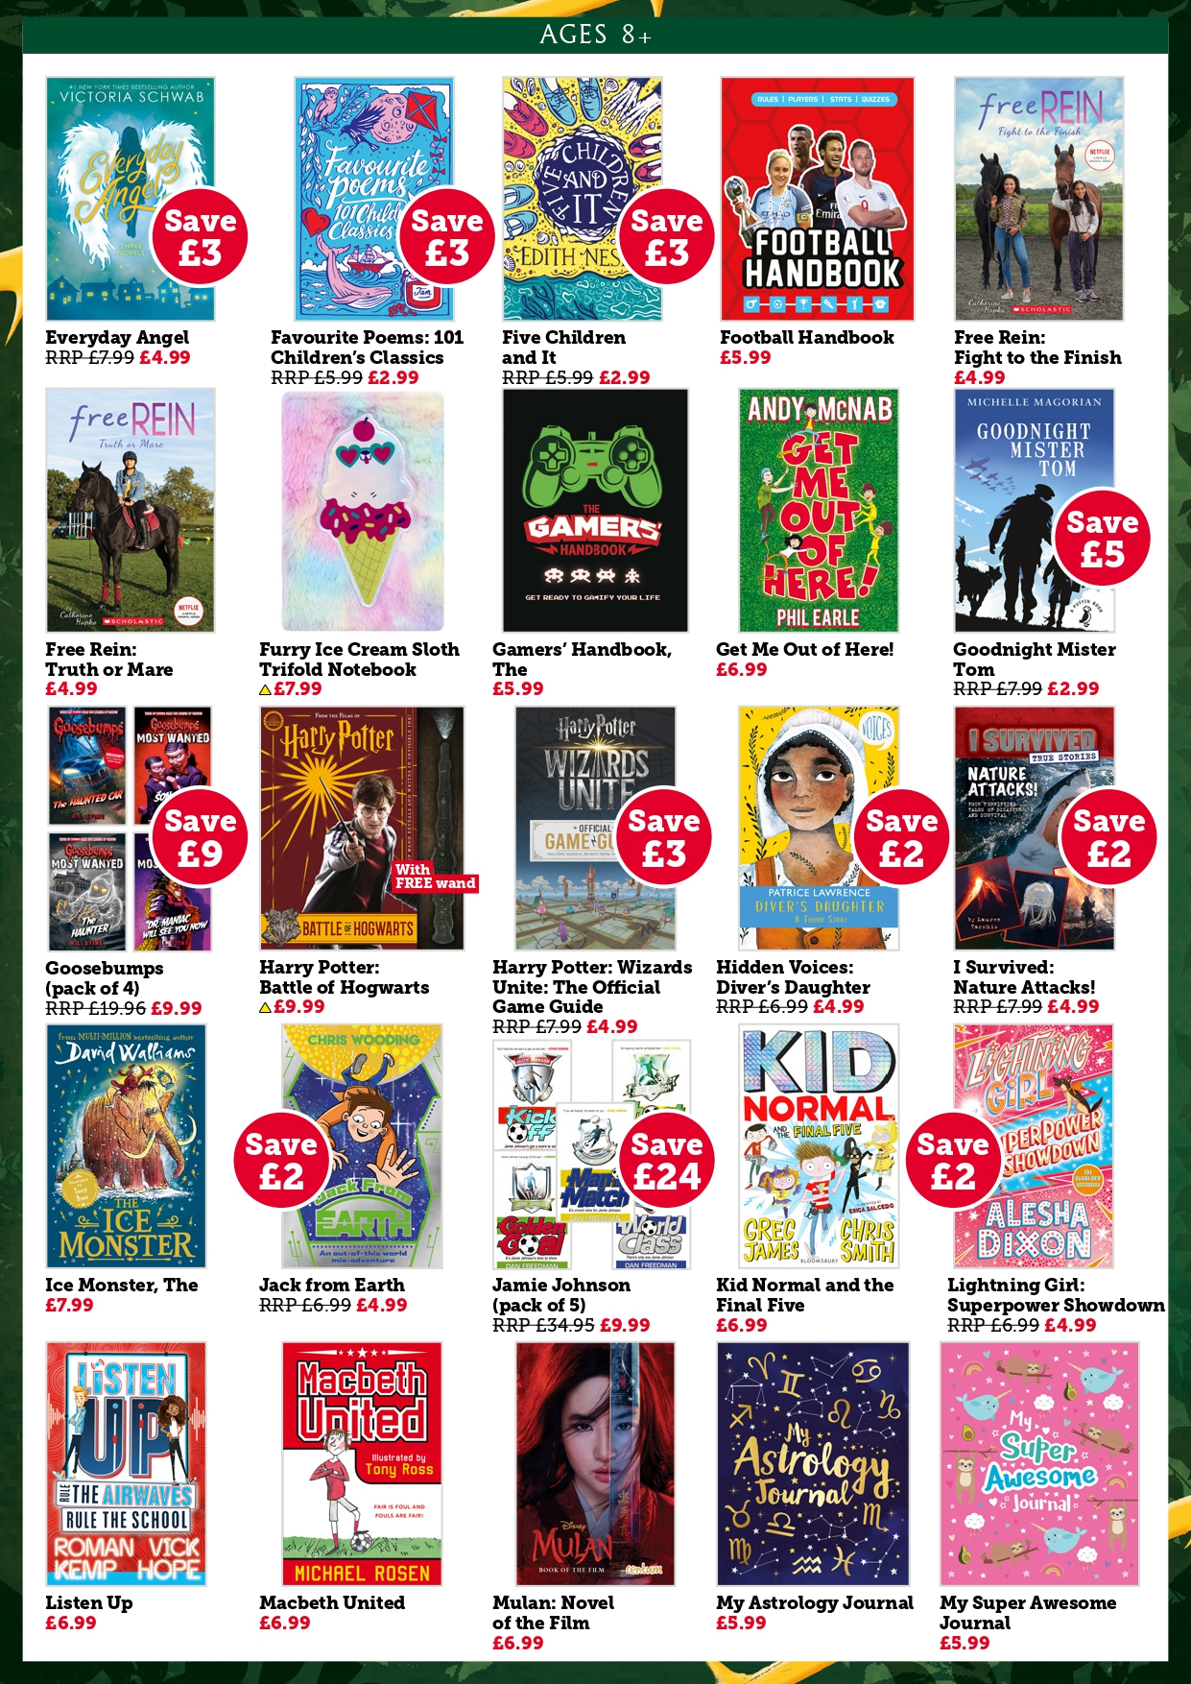

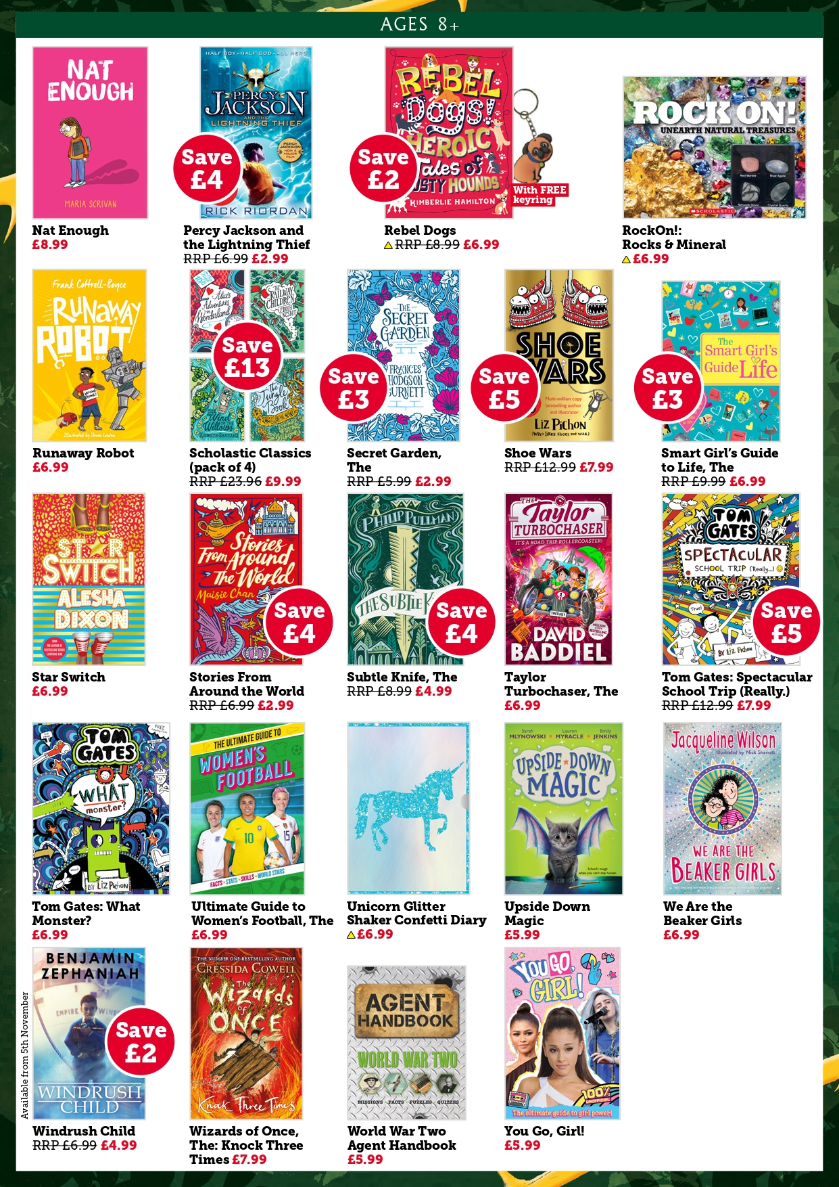

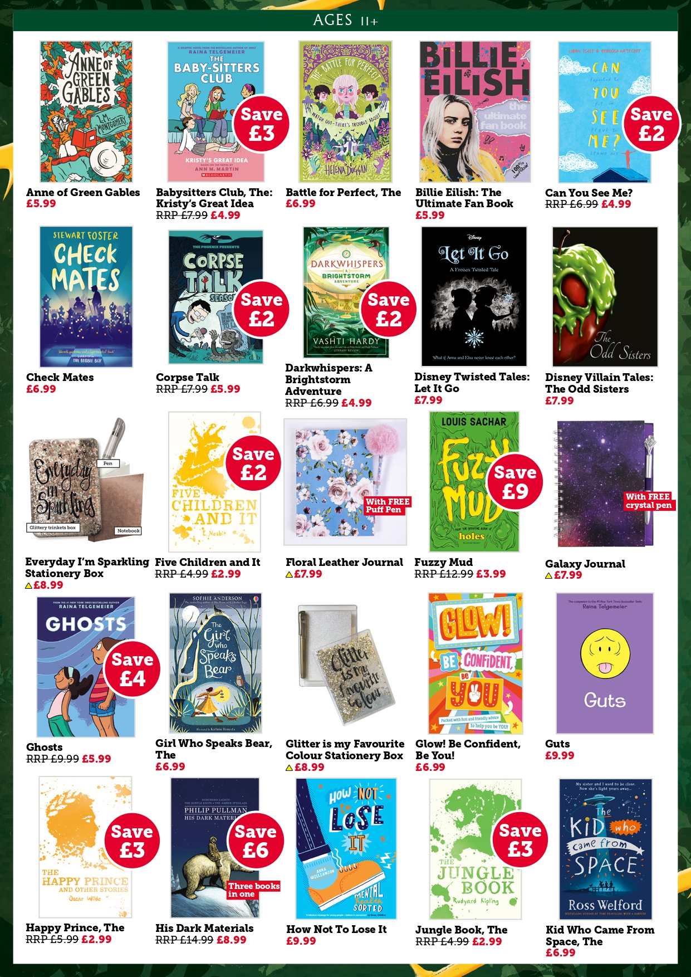

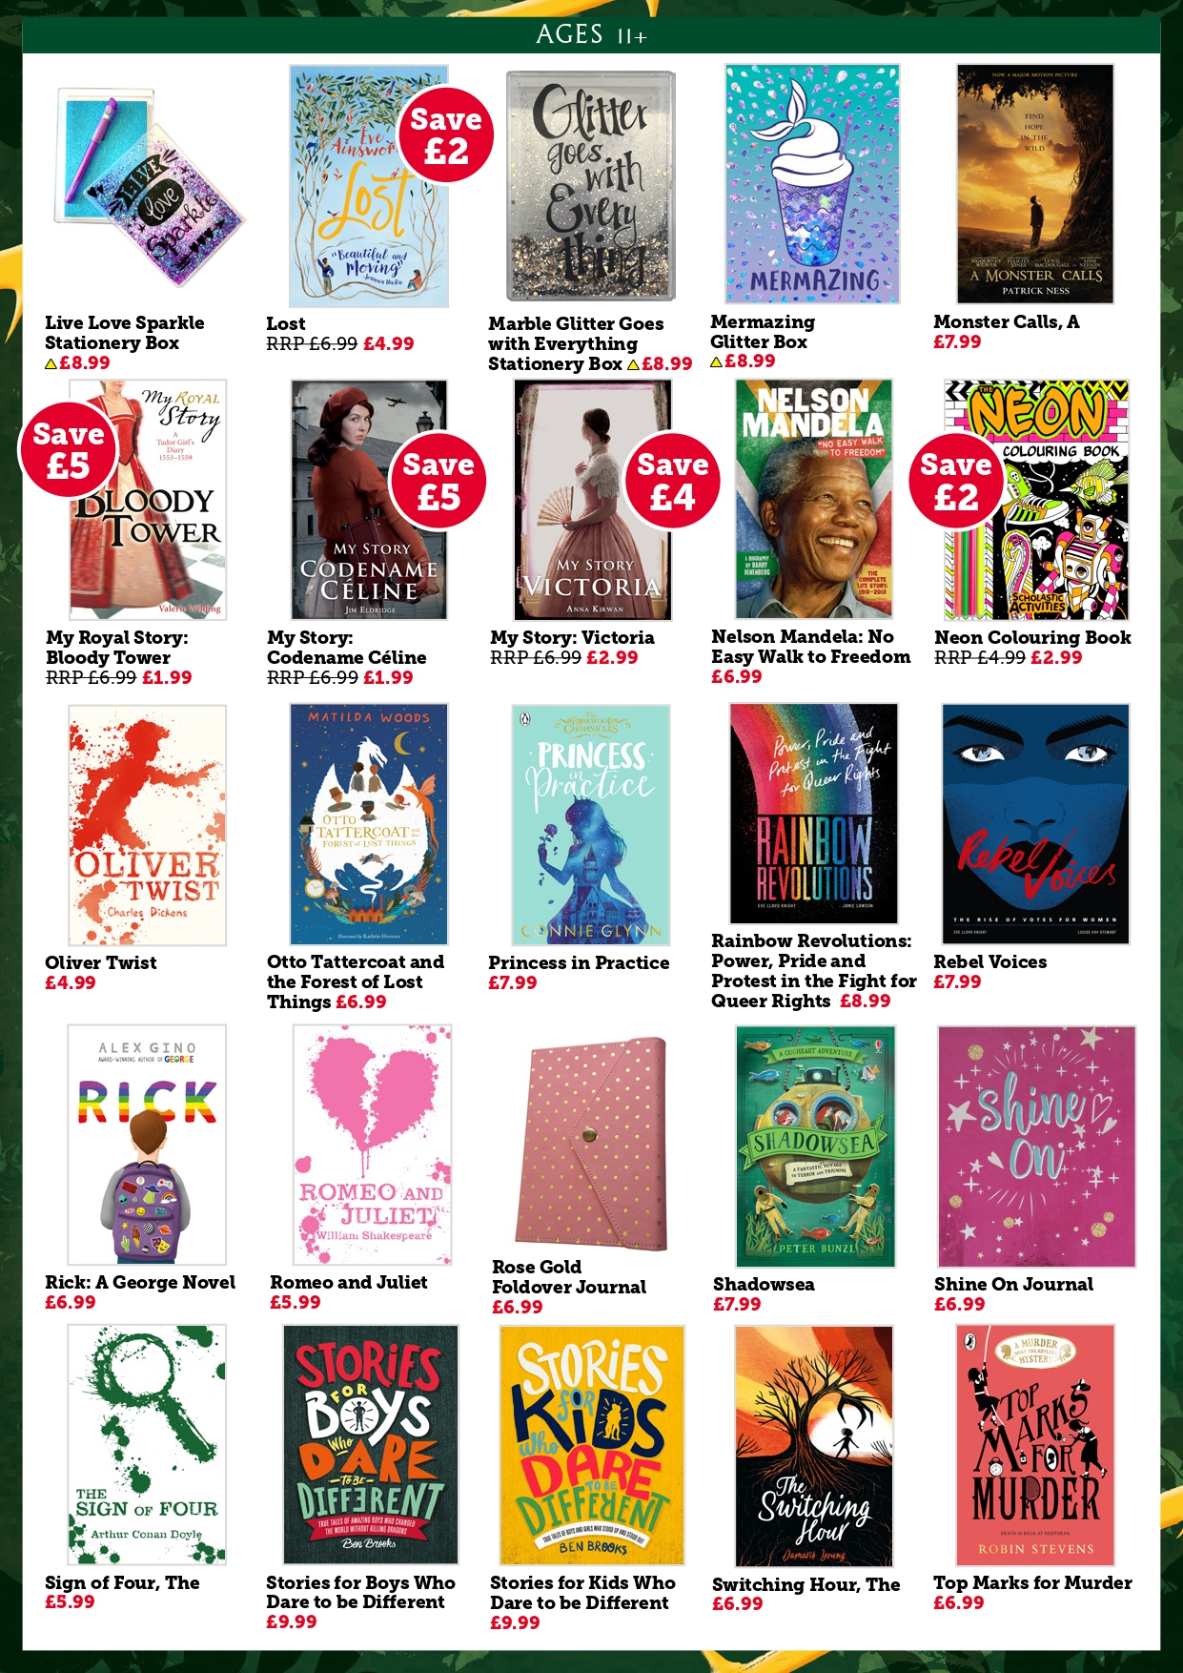

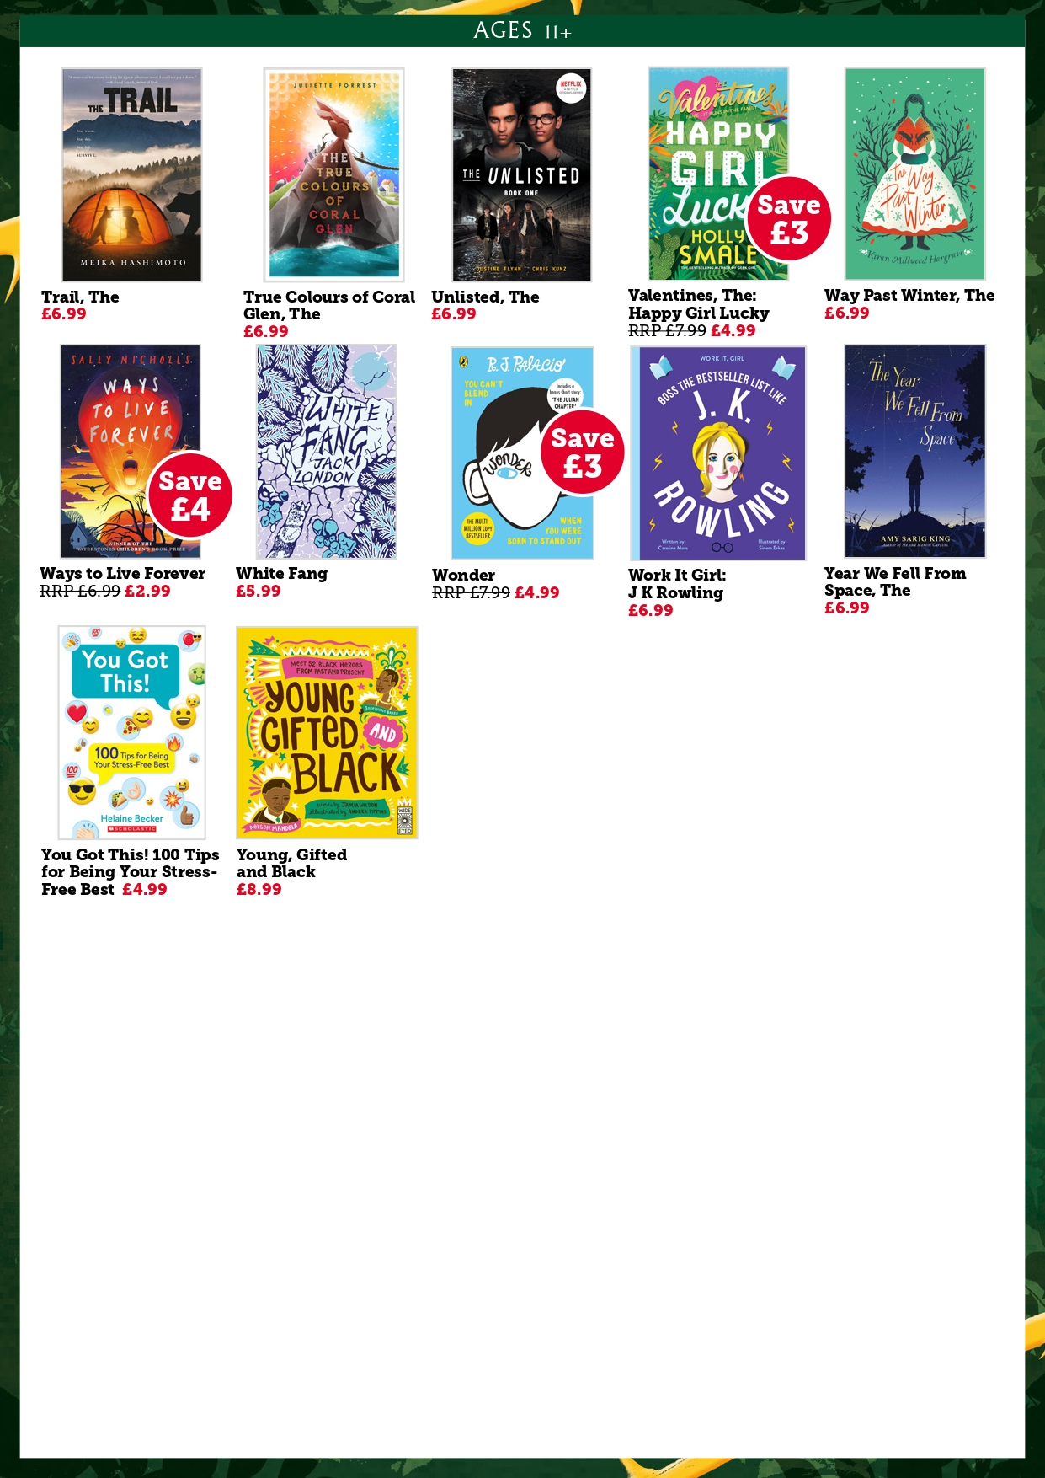

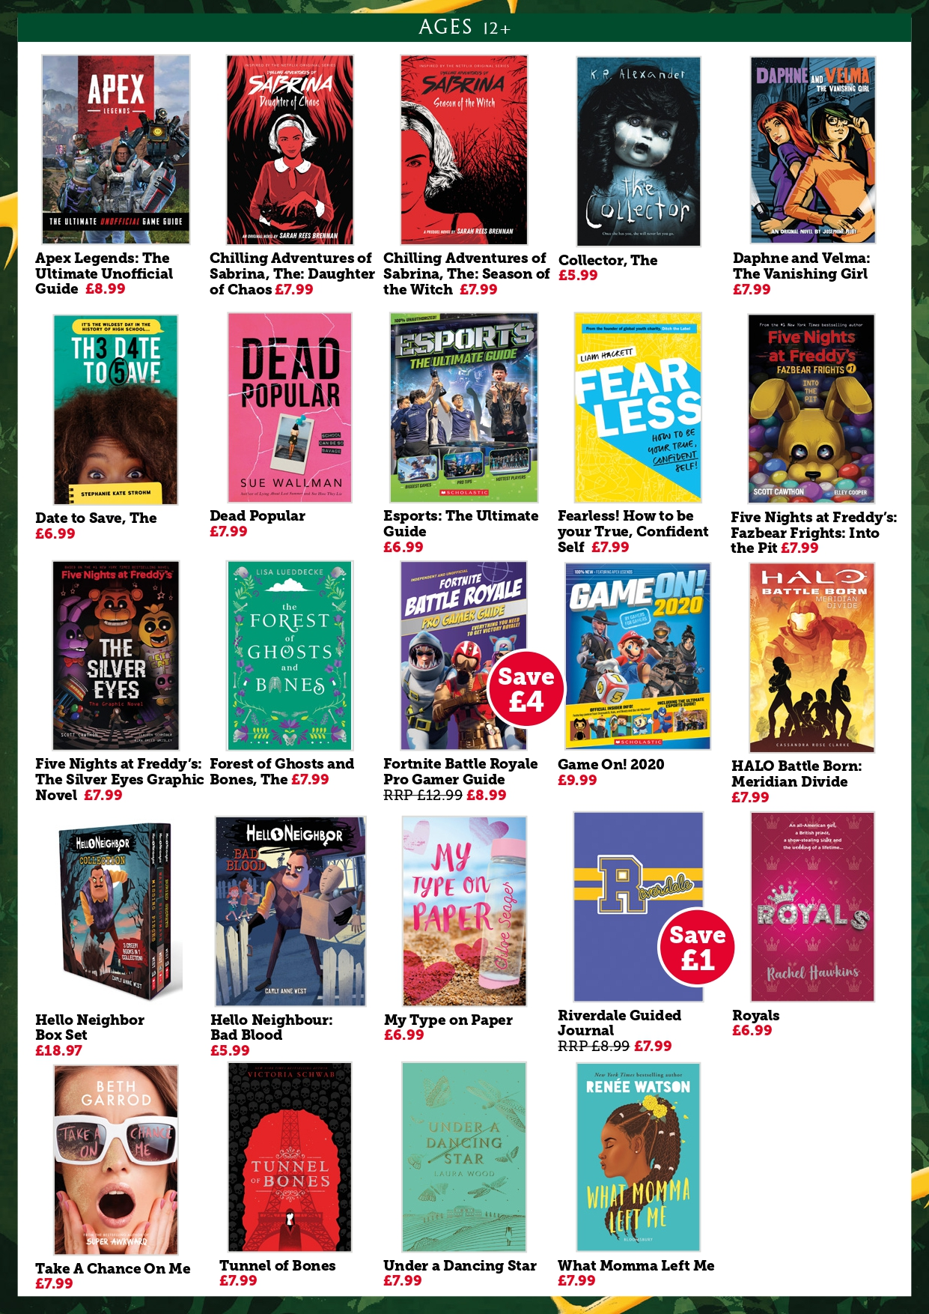

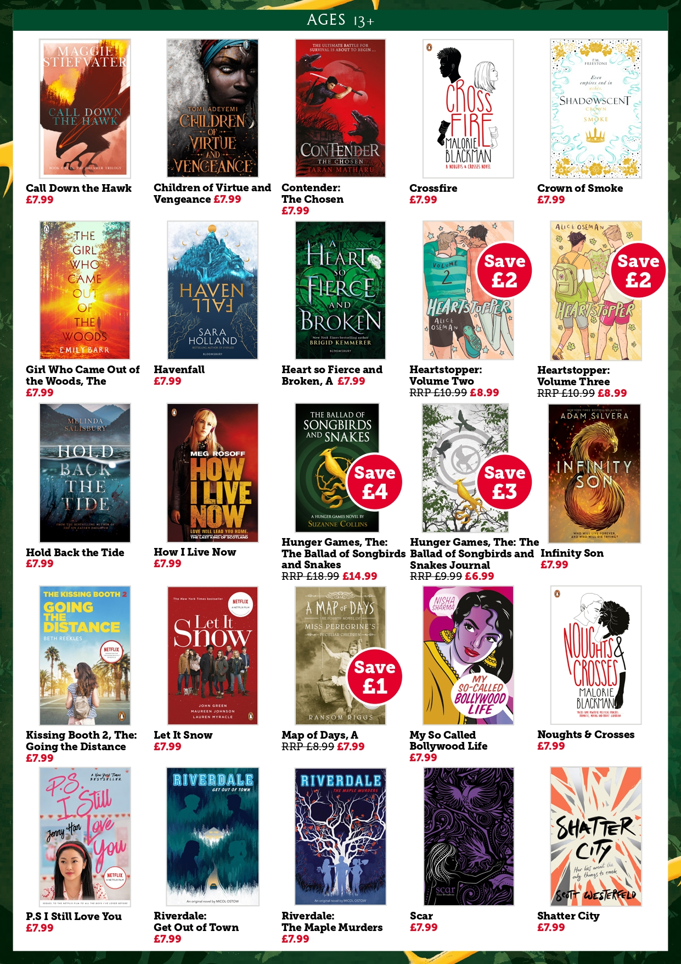

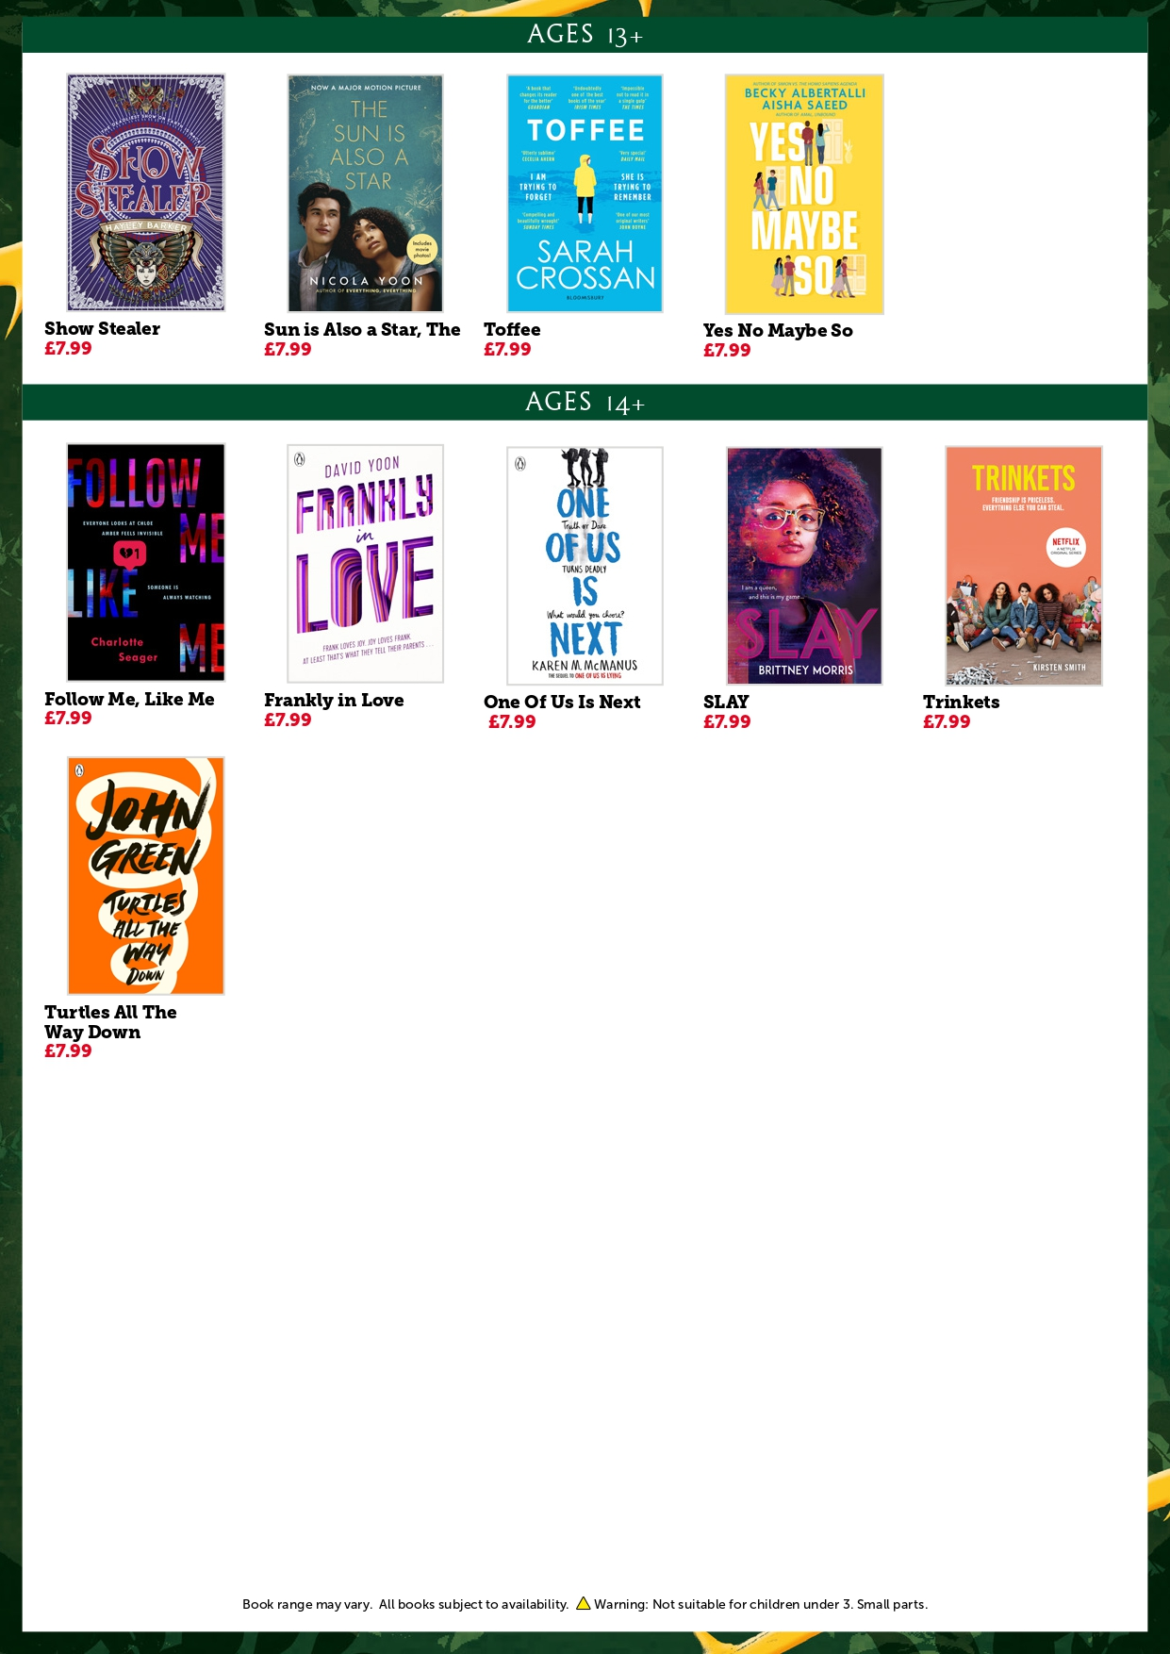


If you join your school’s Book Fair order you’ll benefit from FREE P+P to your school! Just fill in the order form and return it to Mr. Richardson in school along with the correct payment, or to richardson_l@trinityhigh.com and make payment using the secure Pay by Phone service – details below.

Title |  |  | Price | Quantity |  | Total
 |  |  | Total Order Value
Student’s name: |  |  | Class:
Parent’s name:
School name: Trinity C of E High School |  |  | School postcode: WA13 9LJ
Please tell us how you’d like to pay and give details below:
Pay by Phone:
Call 0333 305 2963 Trinity School ID: 11906633
Please have your school’s Customer I.D. number ready together with a pen to record your transaction code.
You will be asked for your card number, expiry date, the three digit security number on the back of your card and amount you wish to pay. This call will be charged at your standard mobile rate.

Name: |  |  | School customer  I.D. number:
Transaction  Code: |  |  | Transaction  Value:
Pay with Gift Vouchers:
Avoid handling cash with pre-paid gift vouchers. Visit bookfairs.scholastic.co.uk/gift-vouchers to purchase, available in £5, £10, £15, £20 and £25.

Gift Voucher  Code: | G000
Gift Voucher  Value: | £ | Total Order  Value: | £

Pay with Cash or Cheque:
Total Amount  Enclosed: | £ | Please make cheques payable to the school.

Please give the completed slip and payment back to Mr Richardson.

