Job Title: Bricklayer.
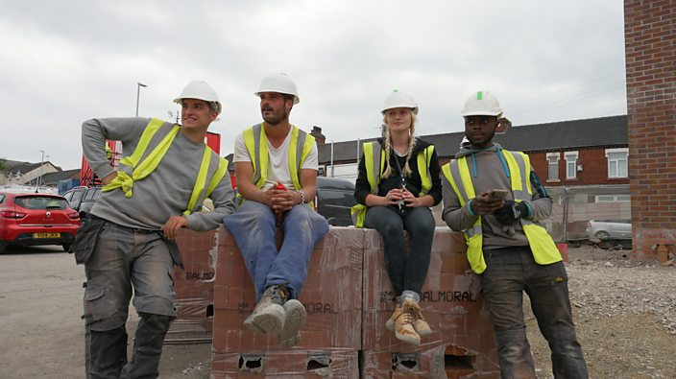
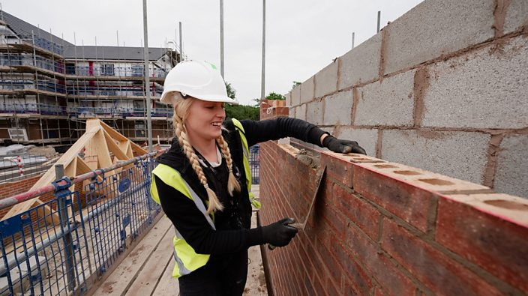

Job Title:  Bricklayer | Bricklayers build houses, repair walls and chimneys and refurbish decorative stonework. They also work on restoration projects.  Why become a Bricklayer? Watch the video in this link  https://www.findapprenticeships.co.uk/bricklaying-apprenticeships/ (Scroll down to the video)  Want to learn more?  https://www.bbc.co.uk/bbcthree/article/90f4edca-535c-4b8c-a175-ea1e4893b304  You can find out more about becoming a bricklayer from Go Construct and House Building Careers.
Entry requirements: | College  You can take a college course like a:  - Level 1 Certificate in Construction Skills  - Level 2 Diploma in Bricklaying  - Level 2 Diploma in Trowel Occupations  - T Level in On Site Construction  These courses teach the skills needed for the job and can help you to find a trainee position with a building company.  Entry requirements  You'll usually need:  - 2 or fewer GCSEs at grades 3 to 1, or equivalent, for a level 1 course  - 2 or more GCSEs at grades 9 to 3, or equivalent, for a level 2 course  - 4 or 5 GCSEs at grades 9 to 4, or equivalent, including English and maths for a T level  Apprenticeship  You can do a bricklaying intermediate apprenticeship.  This will usually take 2 years to complete. You'll do on-the-job training and spend time with a college or training provider.  Entry requirements  You'll usually need:  - some GCSEs, usually including English and maths, or equivalent, for an intermediate apprenticeship  Work  You could start as a construction site labourer with a bricklaying 'gang' and take training on the job to become a bricklayer.  More Information  Registration  - you'll need a Construction Skills Certification Scheme (CSCS) card or equivalent to train and work on a construction site  Professional and industry bodies  You can join an organisation like the Federation of Master Builders for professional recognition and training opportunities.
Skills required: | You'll need:  - knowledge of building and construction  - to be thorough and pay attention to detail  - the ability to work well with others  - to be flexible and open to change  - patience and the ability to remain calm in stressful situations  - the ability to work well with your hands  - physical skills like strength, balance and coordination  - the ability to organise your time and workload  - to be able to carry out basic tasks on a computer or hand-held device
What you'll do: | In your day-to-day tasks you could:  - measure work areas and set out the first rows of bricks or blocks  - mix mortar by hand or with a mechanical mixer  - use a trowel to lay bricks and mortar  - shape and trim bricks using hammers, chisels and power tools  - check that rows are straight using a spirit level, laser level or plumb line
What you’ll earn: | - Starter – £17,000  - Experienced - £52,000  Average Salary - £40,000  These figures are a guide
Working hours, patterns and environment: | You may work between 40 – 44 hours per week.  This could be local or you may have to work away from home, depending on the project you’re working on.  Your working environment may be physically demanding, outdoors in all weathers and at height.  You may need to wear protective clothing.
Career path and progression: | You could specialise in a particular type of bricklaying like heritage work or stonemasonry.  You could become self-employed and set up your own business.  With experience, you could become a construction site supervisor, or move into related areas like estimating, training or teaching apprentices or students in a further education college.

