Job Title: Criminologist
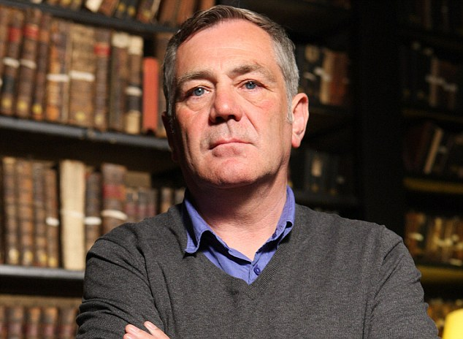


https://www.up.ac.za/alumni/news/post_3028152-up-alumna-becomes-first-black-female-president-of-african-criminological-society-

Job Title:  Criminologist | Criminologists look at the reasons why people commit crimes and find ways to reduce re-offending.  Why become a Criminologist? Watch the video in this link https://www.manchester.ac.uk/study/undergraduate/courses/2023/07052/ba-criminology/ (please scroll down for the video)  Want to learn more?  https://www.prospects.ac.uk/careers-advice/what-can-i-do-with-my-degree/criminology
Entry requirements: | University  You can do a degree in:  - criminology  - criminal justice and psychology  - sociology  - youth justice  - law and criminology  You can also do a postgraduate qualification in criminology. Most degree subjects are accepted for entry but relevant work experience can also be taken into account.  It is useful to get experience through internships, volunteering and work placements during your studies. For example, you could work with adults or young people affected by the criminal justice system, or people who are the victims of crime. This can help you explore the options for future research or criminology specialisms.  Your university careers service can help you find opportunities.  Entry requirements  You'll usually need:  - 3 A levels, or equivalent, for a degree  - A degree in any subject for a postgraduate course  Other Routes  You could apply for a place on the Government Social Research Fast Stream programme to work in the Civil Service.  You'll need an upper second class (2:1) degree or better, in criminology or social sciences, to apply.  More Information  Professional and industry bodies  You could join the British Society of Criminology for professional development and networking opportunities.  Further information  You can find out more about working in crime and justice from GOV.UK.
Skills required: | You'll need:  - knowledge of sociology and anthropology for understanding society and culture  - excellent written communication skills  - knowledge of teaching and the ability to design courses  - analytical thinking skills  - maths knowledge  - to be thorough and pay attention to detail  - the ability to understand people’s reactions  - persistence and determination  - to be able to use a computer and the main software packages confidently
What you'll do: | In this role you could:  - research the reasons why people commit crime  - advise policy makers in the justice and policing systems  - analyse data from surveys and intelligence to spot trends  - work on crime reduction and rehabilitation programmes  - recommend ways to improve the effectiveness of punishments  - visit prisons and probation services to speak to offenders and ex-offenders  - attend conferences and present research findings  - teach students at college or university
What you’ll earn: | - Starter – £23,500  - Experienced - £54,000  Average Salary - £46,000  These figures are a guide
Working hours, patterns and environment: | You may work between 37 - 40 hours per week, usually Monday to Friday.  You could work in an office, in a prison or visit sites.  Your working environment may be emotionally demanding and you may spend nights away from home.
Career path and progression: | You could become a senior policy adviser on crime and crime reduction with local or national government, the police or the probation service.  You could also work as a specialist researcher in particular offences, for example online abuse, organised crime or youth offending.  You could have an academic career in a university and become a professor of criminology.  With further training, you might move into social or probation work, a career in law or join the security services.

