Job Title: Environmental
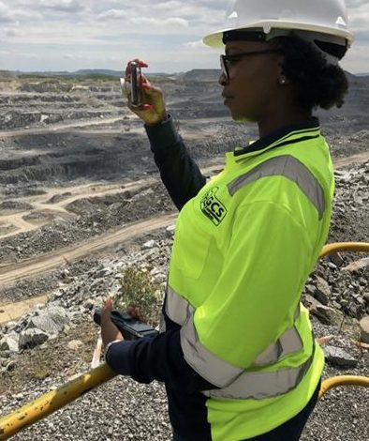
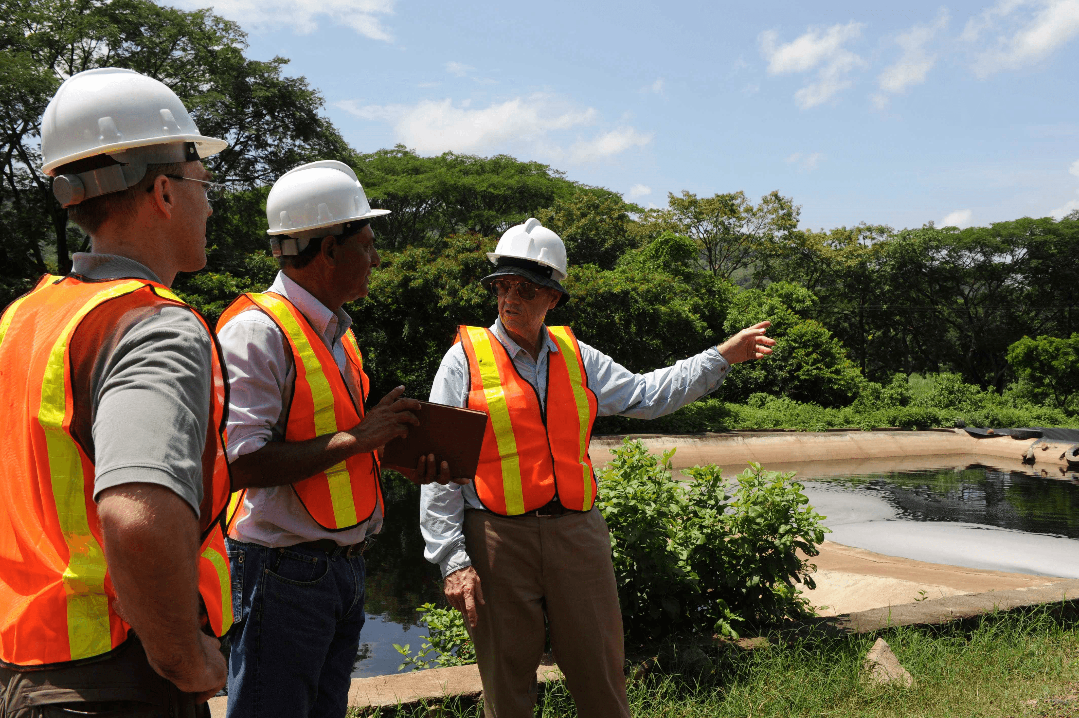
Consultant

Job Title:  Environmental Consultant | Environmental consultants advise on sustainability, including waste management, recycling, flood risk and the effects of climate change.  Why become an Environmental Consultant? Watch the video in this link  https://www.youtube.com/watch?v=DXI30C57idI  Want to learn more?  https://www.prospects.ac.uk/job-profiles/environmental-consultant
Entry requirements: | University  You'll usually need a degree or postgraduate qualification in environmental science, environmental studies or environmental sustainability.  You might also be able to take a related subject like:  - biology  - chemistry  - geoscience  - ecology  - agricultural science  Entry requirements  You'll usually need:  - 3 A levels, or equivalent, for a degree  - A degree in a relevant subject for postgraduate study  Apprenticeship  You could start by doing an Environmental Practitioner Level 6 Degree Apprenticeship.  This can take up to 5 years to complete.  Entry requirements  You'll usually need:  - 4 or 5 GCSEs at grades 9 to 4 and A levels, or equivalent, for a degree apprenticeship  More Information  higher and degree apprenticeships  Volunteering  Volunteering is a great way of getting experience and a taste of environmental work. It will also give you the opportunity to develop your skills and make contacts.  Organisations who offer volunteering opportunities include:  - The Conservation Volunteers  - National Trust  - The Wildlife Trusts  You can find more opportunities through the Countryside Jobs Service.  More Information  Career tips  As a graduate you could look for environmental postgraduate training positions offered through a Knowledge Transfer Partnership (KTP).  In a KTP, you get the opportunity to run a research project together with an organisation and a university or research body. You may also work towards postgraduate qualifications.  Professional and industry bodies  You can join the Society for the Environment for professional development and making contacts.  Further information  You can discover more about environmental work and training through the:  - Chartered Institute of Ecology and Environmental Management  - Green Careers Hub
Skills required: | You'll need:  - knowledge of geography  - maths knowledge  - analytical thinking skills  - thinking and reasoning skills  - excellent verbal communication skills  - to be thorough and pay attention to detail  - excellent written communication skills  - the ability to use your judgement and make decisions  - to be able to use a computer and the main software packages confidently
What you'll do: | As an environmental consultant, you could:  - assess potential impacts from industrial, commercial and environmental development projects  - collect and analyse survey data from sites  - write scientific reports and present findings  - respond to environmental accidents and manage clean-up operations  - provide policy advice to businesses, landowners and the government  - advise organisations on environmental laws and sustainability
What you’ll earn: | - Starter – £25,000  - Experienced - £60,000  Average Salary - £45,000  These figures are a guide
Working hours, patterns and environment: | You may work between 37 - 39 hours per week, including occasional evenings.  You could work in an office or at a client's business.  Your working environment may be outdoors some of the time and you'll travel often.
Career path and progression: | With experience, you could:  - move into a senior or principal consultant position  - apply for chartered environmentalist status  - work as a lecturer in education  - run your own consultancy business  - get involved in environmental research

