Job Title: Hair Stylist.

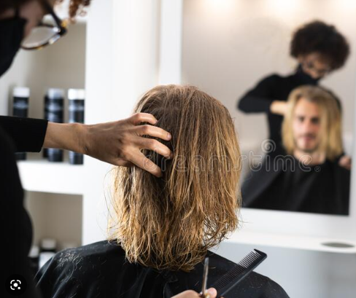

Job Title:  Hair Stylist | Hair Stylists cut, style and colour clients' hair to create the look they want...  Why become a Hair Stylist? Watch the video in this link  https://www.youtube.com/watch?v=UhhL4V5CgtE  Want to learn more?  Check out this website  https://www.hairandbeautyjobs.com/article/career-as-a-hair-stylist
Entry requirements: | You could get into this job through:  - a college course  - an apprenticeship  - working towards this role  College  You could take a course at college that will give you some of the skills and knowledge to do this job.  Courses include:  - Level 2 or 3 Diploma in Hairdressing  - T Level in Hair, Beauty and Aesthetics  You may be able to combine these courses with other areas linked to the fashion and beauty industry.  Entry requirements  You'll usually need:  - 2 or more GCSEs at grades 9 to 3 or equivalent, for a level 2 course  - 4 or 5 GCSEs at grades 9 to 4 or equivalent, for a level 3 course  - 4 or 5 GCSEs at grades 9 to 4 or equivalent, including English and maths for a T level  More Information  - guide to T levels  Apprenticeship  The following apprenticeships may be relevant to this role:  - Level 2 hair professional  - Level 3 advanced and creative hair professional  Entry requirements  You'll usually need:  - some GCSEs, usually including English and maths, or equivalent, for an intermediate apprenticeship  - 5 GCSEs at grades 9 to 4 or equivalent, including English and maths, for an advanced apprenticeship  More Information  - equivalent entry requirements  - guide to apprenticeships  Work  You may be able start work as a trainee hair stylist and learn on the job. Your employer would expect you to take qualifications part-time, either at a college or in their own training school.  Career tips  You may be able to work freelance and rent space in a salon, though you may have to supply your own equipment.  With experience and an interest in business, you could move up to manage or own your own salon. If this is your aim, it may help to gain some business qualifications alongside hair stylist experience.  Further information  You can find out more about careers in hair styling from the Hair and Beauty Industry Authority and National Hair and Beauty Federation.
Skills required: | You'll need:  - customer service skills  - to be thorough and pay attention to detail  - patience and the ability to remain calm in stressful situations  - excellent verbal communication skills  - the ability to work well with others  - to be flexible and open to change  - the ability to work well with your hands  - active listening skills  - to be able to carry out basic tasks on a computer or hand-held device
What you'll do: | As a junior hair stylist, you'll:  - welcome customers  - shampoo and condition hair  - cut simple styles  - make sure towels and hair products are well stocked  - keep the salon clean and tidy  - make appointments  As a more senior hair stylist, you'll:  - talk to clients and suggest style ideas  - cut and style hair  - give advice on minor hair and scalp problems  - take payments  - order stock and promote products to customers  - keep up to date with new trends, techniques and hair products
What you’ll earn: | - Starter – £14,000  - Experienced - £30,000  Average Salary - £25,600  These figures are a guide
Working hours, patterns and environment: | You could work in a salon, at a client's home, at a health spa, at a store, at an adult care home or on a cruise ship. This is likely to include evenings and weekends.  Your working environment may be physically demanding.  A typical working week is 37 – 40 hours per week.
Career path and progression: | With experience, you could become a senior stylist or salon manager.  With further qualifications, you could also move into training or assessing student hair stylists.  You could become self-employed or open your own salon.  You may be able to use your skills as a hair professional in the theatre, film or television industry.

