Job Title: Live Sound Engineer.
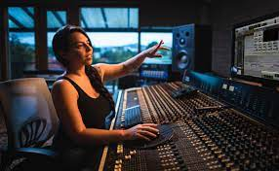
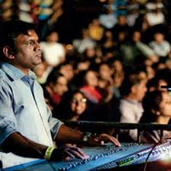

Job Title:  Live Sound Engineer | Live sound engineers control the sound at events like theatre performances, music concerts and festivals.  Why become a Live Sound Engineer? Watch the video in this link  https://youtu.be/S9dG_aCBZew  Want to learn more?  https://www.dbsinstitute.ac.uk/career-spotlight-live-sound-engineer
Entry requirements: | University  You can do a foundation degree, higher national diploma, or degree in a related subject like:  - sound and live event production  - live sound and lighting technology  - music technology  - technical theatre art  Entry requirements  You'll usually need:  - 2 A levels, or equivalent, for a foundation degree or higher national diploma  - 3 A levels, or equivalent, for a degree  College  Some sound engineers start by taking a college course to develop their skills before looking for work. Qualifications include:  - Level 2 Diploma in Sound and Music Technology  - Level 3 Certificate in Technical Theatre: Sound, Light and Stage  - T Level in Media, Broadcast and Production  Entry requirements  You'll usually need:  - 2 or more GCSEs at grades 9 to 3 or equivalent, for a level 2 course  - 4 or 5 GCSEs at grades 9 to 4 or equivalent, for a level 3 course  - 4 or 5 GCSEs at grades 9 to 4 or equivalent, including English and maths for a T level  Apprenticeship  The following advanced apprenticeships may be relevant:  - Live events rigger  - Live event technician  - Creative venue technician  You could also do an Acoustics technician higher apprenticeship.  Entry requirements  You'll usually need:  - 5 GCSEs at grades 9 to 4 or equivalent, including English and maths, for an advanced apprenticeship  - 4 or 5 GCSEs at grades 9 to 4 and A levels, or equivalent, for a higher or degree apprenticeship  More Information  guide to apprenticeships  Volunteering  You can get practical experience of using sound equipment to help your career prospects. This may be part of a course or you can try:  - helping backstage in a theatre  - rigging sound in amateur or student theatre, or for local bands  - working for a sound equipment manufacturer or hire company  Other Routes  Several drama schools offer degrees and diplomas in technical theatre accredited by the Federation of Drama Schools. Some of these courses include lighting and stage management as well as sound.  More Information  You can find out more about becoming a live sound engineer from Spotlight.  You can get more information on working in creative careers from Discover Creative Careers.
Skills required: | You'll need:  - to be thorough and pay attention to detail  - knowledge of computer operating systems, hardware and software  - the ability to work well with others  - the ability to accept criticism and work well under pressure  - to be flexible and open to change  - persistence and determination  - customer service skills  - knowledge of media production and communication  - to be able to use a computer and the main software packages competently
What you'll do: | You might:  - discuss the production sound needs with the director or sound designer  - identify places in the script where any sound effects, music and changes in sound level are needed  - pre-record any sound effects and music  - position and rig up microphones  - complete sound checks before a performance  - operate the sound desk during shows  - follow a sound plan (known as a 'plot') and cues from the deputy stage manager  - look after and repair equipment  - unload, set up, dismantle and load equipment at each venue when on tour
What you’ll earn: | - Starter – £25,000  - Experienced - £68,000  Average Salary - £48,500  These figures are a guide
Working hours, patterns and environment: | You may work between 39 – 41 hours per week, including evenings and weekends.  You could work in a theatre, at events or at a recording studio.  Your working environment may be at height, outdoors some of the time and you may spend nights away from home.
Career path and progression: | With experience, you could progress to chief sound engineer in a theatre, become a sound designer, or set up your own sound services company.

