Job Title: Mechanical
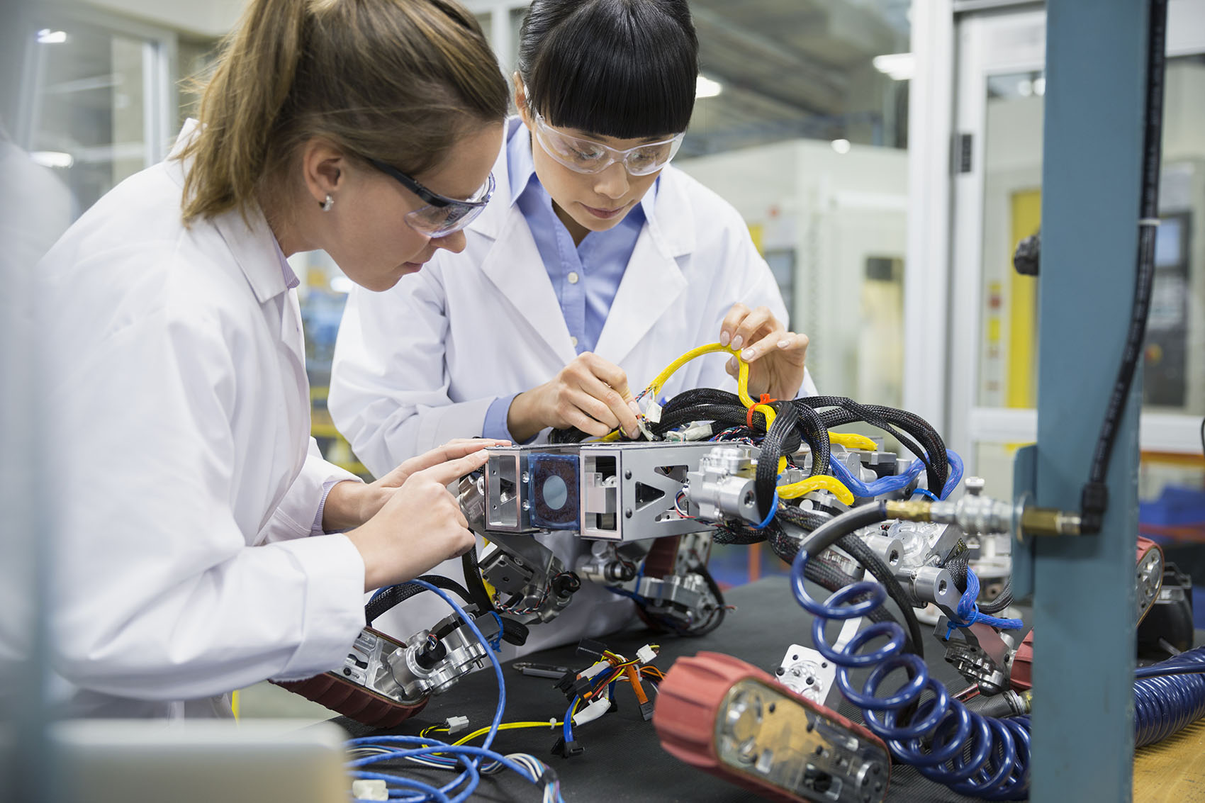
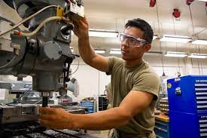
Engineer.

Job Title:  Mechanical Engineer | Mechanical engineers research and design mechanical products and systems, and oversee them being made, used and repaired.  Why become a Mechanical Engineer? Watch the video in this link  https://www.birmingham.ac.uk/undergraduate/courses/mechanical-engineering/mechanical-engineering-beng.aspx  Scroll down a little way for the video  Want to learn more?  https://www.prospects.ac.uk/job-profiles/mechanical-engineer
Entry requirements: | University  You could do a higher national diploma or degree in subjects like:  - mechanical engineering  - electromechanical engineering  - mechatronics  - engineering manufacturing  The Engineering Development Council has information on accredited courses.  You should try to get some work experience during your course through things like:  - internships  - summer or Easter vacation schemes  - a year placement in industry  - a science, technology, engineering and maths (STEM) ambassador scheme  This will help you to make contacts and gain work skills that will be useful when you start applying for graduate jobs.  Your university careers service can help you find suitable opportunities.  Entry requirements  You'll usually need:  - 3 A levels, or equivalent, including maths and physics  College  You could do a Level 4 and 5 Higher National Diploma in Mechanical Engineering at college before looking for work.  You can get work experience and make contacts in the industry, through year in industry schemes like those run by the Engineering Development Trust.  Entry requirements  You'll usually need:  - 2 A levels, a level 3 diploma or relevant experience for a level 4 or level 5 course  Apprenticeship  You could do a higher or degree apprenticeship to become a mechanical engineer.  Some relevant apprenticeships include:  - Manufacturing engineer degree apprenticeship  - Electro-mechanical engineer higher apprenticeship  - Power and propulsion gas turbine engineer higher apprenticeship  Entry requirements  You'll usually need:  - 5 GCSEs at grades 9 to 4 and A levels, or equivalent, for a higher or degree apprenticeship  More Information  - guide to apprenticeships  Work  You could start as a mechanical engineering technician and do further training on the job to qualify as an engineer.  More Information  Further information  You can find out more about how to become an engineer through the:  - Institution of Mechanical Engineers  - Tomorrow's Engineers
Skills required: | You'll need:  - maths knowledge  - knowledge of engineering science and technology  - design skills and knowledge  - the ability to use, repair and maintain machines and tools  - analytical thinking skills  - to be thorough and pay attention to detail  - knowledge of physics  - the ability to come up with new ways of doing things  - to be able to use a computer and the main software packages competently
What you'll do: | You could:  - turn research ideas into technical plans, using computer aided design/modelling (CAD/CAM)  - carry out surveys of mechanical systems and equipment  - research and assess new products and innovations  - present design plans and data to managers and clients  - produce other technical documents  - support the contract team when bidding for new work  - oversee maintenance programmes and quality control  - manage and lead a project team of technicians, designers and other engineering professionals
What you’ll earn: | - Starter – £20,000  - Experienced - £52,000  Average Salary - £42,500  These figures are a guide
Working hours, patterns and environment: | You may work between 36 - 40 hours per week, including evenings and weekends .  You could work in an office, in a factory or visit sites.  Your working environment may be outdoors in all weathers.
Career path and progression: | You may be able to use your skills in private or public sector companies in different industries, like:  - manufacturing  - construction  - energy and utilities  - government organisations  With experience you could work towards incorporated or chartered engineer status. You could move into people, business or project management roles. You may specialise in a particular field, work in research and development or become an engineering consultant.  You could also teach in a further education college.  Find out more about teaching in further education from Teach in further education.

