Job Title: Primary School
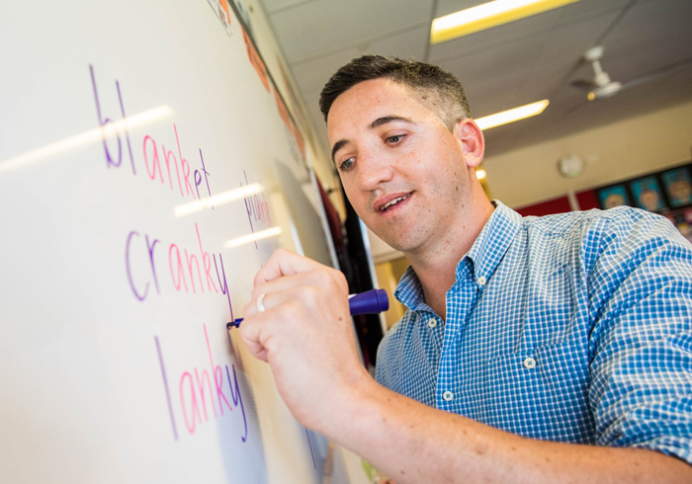
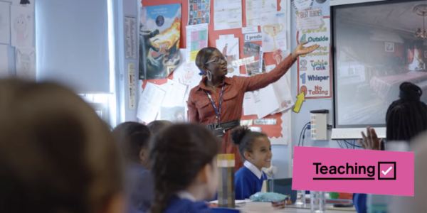
Teacher

Job Title:  Primary School Teacher | Primary school teachers are responsible for the educational, social and emotional development of children from age 5 to 11.  Why become a Primary School Teacher? Watch the video in this link  https://www.youthemployment.org.uk/explore-shaniquas-journey-to-becoming-a-primary-school-teacher-getintoteaching/  Scroll down a little way for the video  Want to learn more?  https://www.prospects.ac.uk/jobs-and-work-experience/job-sectors/teacher-training-and-education/how-much-do-teachers-get-paid
Entry requirements: | University  Undergraduate degree  You can do an undergraduate degree that leads to qualified teacher status (QTS), for example:  - Bachelor of Education (BEd)  - Bachelor of Arts (BA) with QTS  - Bachelor of Science (BSc) with QTS  Postgraduate certificate  If you already have a bachelor's degree without qualified teacher status, you can complete a postgraduate certificate in education (PGCE). This can be done at university or through a training programme based in a school.  More teacher training options  There are more training options if you want to change career or specialise in teaching certain subjects.  Entry requirements  You'll usually need:  - 5 GCSEs at grades 9 to 4, or equivalent, including English, maths and science  - 3 A levels, or equivalent, for a degree  - A degree in any subject for a postgraduate course  More Information  - postgraduate teacher training courses  Apprenticeship  You can do a degree level teaching apprenticeship if you have a degree and want to teach 5 to 11 year olds.  Entry requirements  You'll usually need:  - GCSEs at grades 9 to 4 in English and maths  - GCSE science at grade 9 to 4 for primary school teaching  - A degree for a teaching apprenticeship  More Information  - postgraduate teaching apprenticeships  Work  You could start as a teaching assistant and do a part time degree. You could then move onto a postgraduate teaching course to qualify as a teacher.  Volunteering  You'll find it helpful to get some experience of working with children, though this is not essential.  You could volunteer at a school, help at an after school club or work on a holiday scheme.  More Information  Registration  - you'll usually need qualified teacher status (QTS) to teach in a state school in England  Further information  You can discover more about how to become a teacher from Get Into Teaching.
Skills required: | You'll need:  - knowledge of teaching and the ability to design courses  - sensitivity and understanding  - the ability to create the best conditions for learning or teaching new things  - the ability to work well with others  - to be flexible and open to change  - knowledge of English language  - patience and the ability to remain calm in stressful situations  - excellent verbal communication skills  - to be able to use a computer and the main software packages competently  Restrictions and Requirements  You'll need to:  - pass enhanced background checks
What you'll do: | In this role you could:  - prepare teaching materials, set up the classroom and organise displays  - plan and teach lessons and work with small groups of students  - mark work and talk to parents and carers about their children's progress  - manage the work of teaching assistants  - follow safeguarding procedures and work with education psychologists and social workers  - organise trips, after school clubs and sports events  - work and attend meetings and training
What you’ll earn: | - Starter – £30,000  - Experienced - £46,425 (most primary school teachers will get to this point during their career). Teachers can then earn more by taking on further responsibility.  - Headteacher - £60,000 and above (depending on the school setting)  These figures are a guide
Working hours, patterns and environment: | You may work between 37 - 45 hours per week, plus evenings and weekends.  You could work at a school or at a pupil referral unit.
Career path and progression: | With experience you could:  - become a special educational needs teacher or move into pastoral care  - become a specialist leader of education and support teachers in other schools  - be a curriculum leader, deputy head or headteacher  - move into private tuition  - teach overseas in an international school

