Job Title: Radiographer.
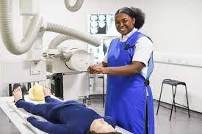
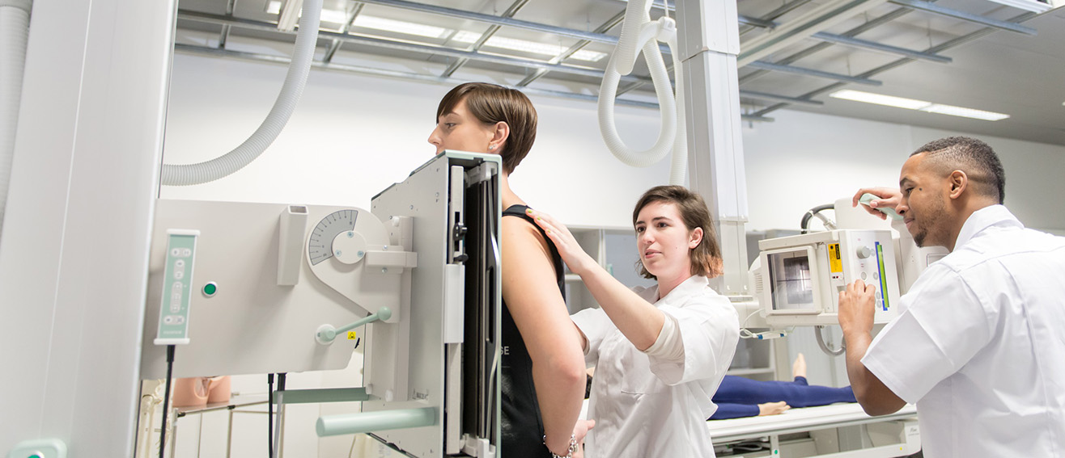

Job Title:  Radiographer | Radiographers use equipment to diagnose or treat patients who are ill or injured.  Why become a Radiographer? Watch the video in this link  https://www.healthcareers.nhs.uk/explore-roles/allied-health-professionals/roles-allied-health-professions/roles-allied-health-professions/diagnostic-radiographer/diagnostic  https://www.healthcareers.nhs.uk/explore-roles/allied-health-professionals/roles-allied-health-professions/roles-allied-health-professions/therapeutic-radiographer  Want to learn more?  https://www.webmd.com/a-to-z-guides/what-is-radiographer
Entry requirements: | University  You'll need to do an approved degree or postgraduate qualification, which allows you to register with the Health and Care Professions Council. You'll need registration to work.  Before you apply for a course, you'll need to think about whether you want to work in diagnostic radiography or therapeutic radiography. Visiting a radiography department at your local hospital may help you decide.  Diagnostic Radiography – As a diagnostic radiographer, you'll work in a range of hospital departments, acquiring images to help with the diagnosis of illnesses and injuries.  You'll work with the latest imaging methods such as:  - angiography  - computerised tomography (CT)  - fluoroscopy  - MRI (magnetic resonance imaging)  - ultrasound  - x-ray.  Therapeutic Radiography – this is the use of radiation to plan and treat patients suffering with cancer. The accuracy of these is critical to treat the tumour and destroy the diseased tissue, while minimising the amount of exposure to surrounding healthy tissue.  If you're a health professional or a graduate with a relevant first degree, you may be able to take a fast-track postgraduate qualification over 2 years.  You may be able to get additional student financial support through the NHS Learning Support Fund.  You'll usually need:  - 5 GCSEs at grades 9 to 4, or equivalent, including English, maths and science  - 3 A levels, or equivalent, including at least 1 science  - A degree in a relevant subject for postgraduate study  Apprenticeship  You may be able to do a diagnostic or therapeutic radiographer degree apprenticeship.  This typically takes 36 months to complete as a mix of learning in the workplace and academic study at an approved university.  Entry requirements  You'll usually need:  - 5 GCSEs at grades 9 to 4 and A levels, or equivalent, for a higher or degree apprenticeship  Work  You can start as a radiography assistant and work your way up to assistant practitioner. At this level, your employer may give you the opportunity to work and study part-time for a degree and a professional qualification to become a radiographer.  More Information  You can find out more about a career in radiography from Health Careers and the The College of Radiographers.
Skills required: | You'll need:  - knowledge of medicine and medical procedures  - sensitivity and understanding  - to be thorough and pay attention to detail  - knowledge of biology  - the ability to think clearly using logic and reasoning  - active listening skills  - concentration skills  - thinking and reasoning skills  - to be able to use a computer and the main software packages confidently
What you'll do: | As a diagnostic radiographer, you could:  - produce and interpret high quality images of the body to identify and diagnose injury and disease  - screen for abnormalities  - take part in surgical procedures like biopsies (examining tissues to find the cause of disease)  As a therapeutic radiographer, you could:  - plan and give treatment using x-rays and other radioactive sources  - work closely with medical specialists to plan treatment of malignant tumours or tissue defects  - assess and monitor patients through treatment and follow-up
What you’ll earn: | - Starter – £26,000  - Experienced - £46,000  Average Salary - £36,000  These figures are a guide
Working hours, patterns and environment: | You may work between 35 – 40 hours per week.  You could work in an NHS or private hospital or at a hospice.  Your working environment may be physically and emotionally demanding.  You may need to wear protective clothing and a uniform.
Career path and progression: | With experience, you could become a sonography specialist, radiography team leader or consultant practitioner.  You could also take further qualifications to specialise in:  - counselling and palliative care  - the use of certain techniques or equipment  - working with specific groups of patients  - research and teaching

