Job Title: RAF Pilot.
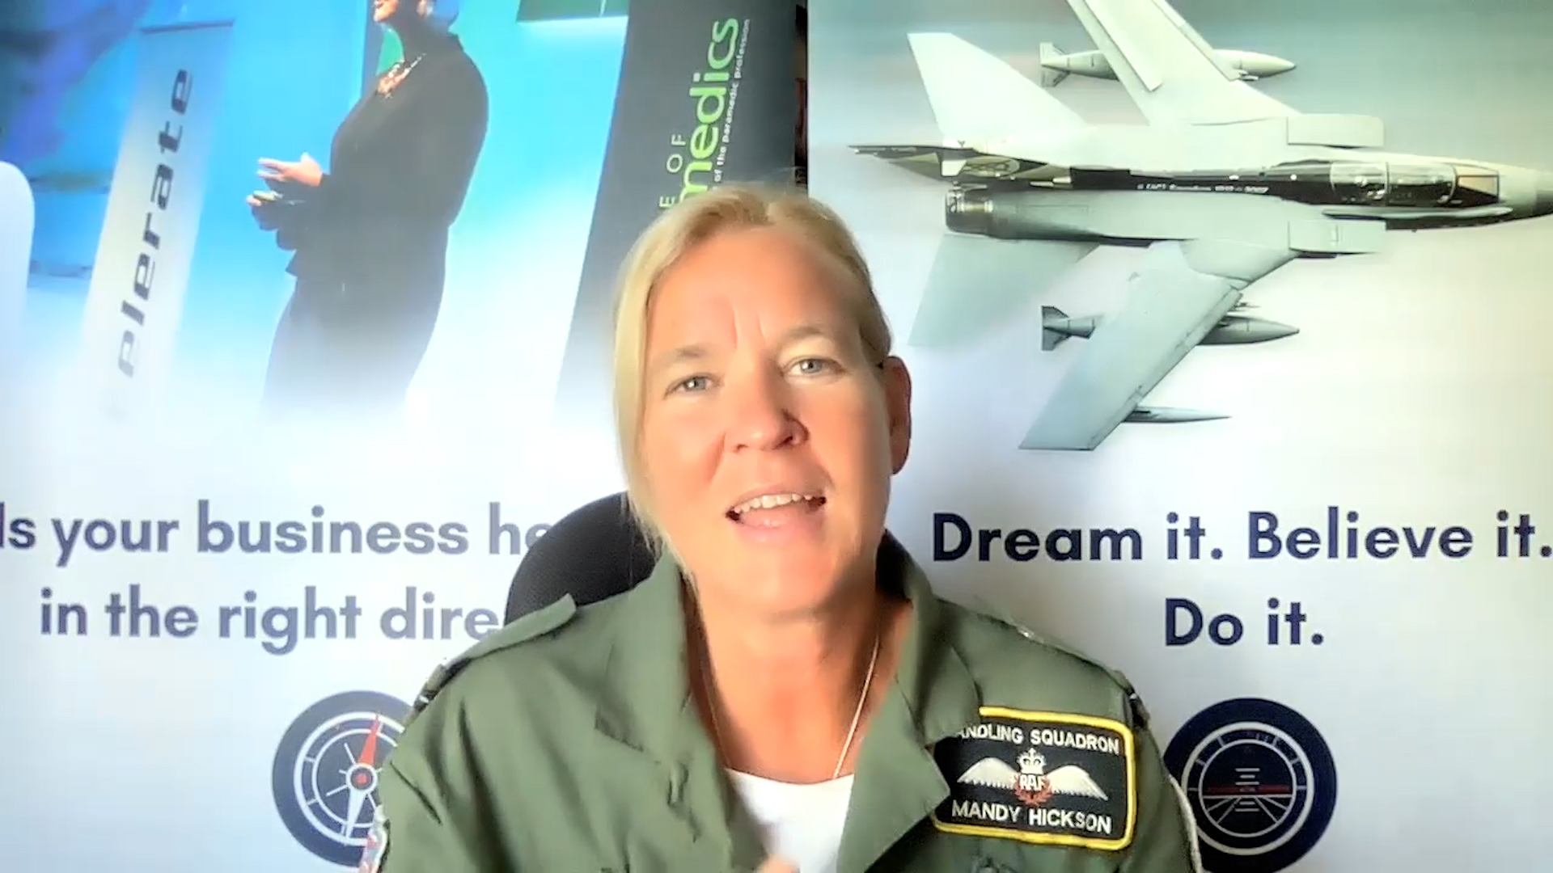
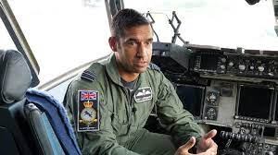

Job Title:  RAF Pilot | As a Royal Air Force Pilot you will fly fast-jets, transport aircraft or helicopters.  Why become a RAF Pilot? Watch the video in this link  https://icould.com/stories/mandy/  Want to learn more?  Check out this website  https://recruitment.raf.mod.uk/roles/roles-finder/aircrew/pilot
Entry requirements: | ALL APPLICANTS MUST:  Be a citizen of the United Kingdom or holder of dual UK/other nationality.  Be aged between 17.5 and 23 years old. (Must enrol before 24th birthday).  Commitment to a minimum of 12 year service.  To train as aircrew in the RAF, you must be able to pass the RAF Swimming Test as follows:  Swim 100 meters without rest, using any front or sidestroke.  Tread water for 2 minutes.  Get out of the deep end of the pool unassisted, without the use of steps or the bottom of the pool.  All personnel attempting the test must wear clothing commensurate with that worn for their normal operating activity, which for aircrew is a flying suit.  Academic Requirements (Minimum)  Five GCSEs (grade 4 or above) including English and Maths  Two A-Levels at grade C or above (which must be at a minimum of 64 UCAS points)
Skills required: | You'll need:  - leadership skills to manage and motivate teams.  - excellent verbal communication skills.  - thinking and reasoning skills for making quick decisions.  - persistence and determination.  - patience and the ability to remain calm in stressful situations.  - concentration skills.
What you'll do: | TYPICAL RESPONSIBILITIES  - Fast-jet pilots conduct air-to-air combat or ground attack missions  - Multi-engine transport pilots fly military support and deliver humanitarian aid  - Helicopter duties range from ferrying troops into combat to delivering equipment and supplies
What you’ll earn: | - Starter – £30,000  - Experienced - £99,500  Average Salary - £60,500  These figures are a guide
Working hours, patterns and environment: | The video in the link above provides a lot of information here
Career path and progression: | With experience you will be able to become promoted and move up through the ranks. This will lead to more responsibility and a higher level of pay.

