Job Title: TV or Film
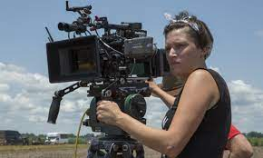
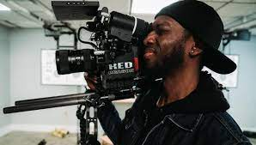
Camera Operator

Job Title:  TV or Film Camera Operator | Camera operators record images for film, television, commercials and online.  Why become a TV or Film Camera Operator? Watch the video in this link https://youtu.be/ViUMsSLUNzQ  Want to learn more?  https://www.prospects.ac.uk/job-profiles/television-camera-operator
Entry requirements: | University  You can take a university course to develop your camera skills before looking for work. Relevant courses include degrees in media production, media technology or photography.  It may give you an advantage if you can find a course that offers practical and work experience opportunities like shadowing, internships or a year placement.  You'll usually need:  - 3 A levels, or equivalent, for a degree  College  You can take a college course like:  - Level 3 Diploma In Creative Media Production and Technology  - Level 3 Diploma in Film and Television Production  - Level 3 Diploma in Photography  - T Level in Media, Broadcast and Production  You'll usually need:  - 4 or 5 GCSEs at grades 9 to 4 or equivalent, for a level 3 course  - 4 or 5 GCSEs at grades 9 to 4 or equivalent, including English and maths for a T level  Apprenticeship  You could learn some of the skills and knowledge needed from related apprenticeships like a photographic assistant or a camera prep technician advanced apprenticeship.  You may be able to transfer the skills you learn to the TV or film industry when you have experience.  You'll usually need:  - 5 GCSEs at grades 9 to 4 or equivalent, including English and maths, for an advanced apprenticeship  Work  You could start out as a camera assistant and learn while you work from an experienced camera operator.  Volunteering  You can get practical experience and build up your contacts through:  - community film projects  - working for a camera equipment hire company  - finding work experience as a runner or camera assistant with a production company  Other Routes  You may be able to apply for the Guild of British Camera Technicians' Trainee Scheme which offers training and mentoring by experienced people working in the industry. The application process is very competitive.  You could search for trainee opportunities with leading TV and film production companies through Screenskills Trainee Finder Scheme.  You can also do short courses through the National Film and Television School.
Skills required: | You'll need:  - to be flexible and open to change  - knowledge of media production and communication  - to be thorough and pay attention to detail  - the ability to work well with others  - the ability to accept criticism and work well under pressure  - the ability to come up with new ways of doing things  - broadcasting and telecommunications knowledge  - excellent verbal communication skills  - to be able to use a computer and the main software packages competently
What you'll do: | In your day-to-day duties you might:  - set up camera equipment  - choose the most suitable lenses and camera angles  - plan and rehearse shots  - follow a camera script  - work closely with other technical departments  - repair and maintain camera equipment
What you’ll earn: | - Starter – £22,000  - Experienced - £79,000  Average Salary - £35,000  These figures are a guide
Working hours, patterns and environment: | You may work between 39 – 41 hours per week, including evenings, weekends and bank holidays.  You could work at a TV studio, at a film studio or on a film set.  Your working environment may be at height, outdoors in all weathers and you may spend nights away from home.
Career path and progression: | With experience, you could become a camera supervisor, cinematographer or director of photography.  You could specialise in a particular field, like underwater filming, aerial photography or wildlife work.

