Job Title: Electrical
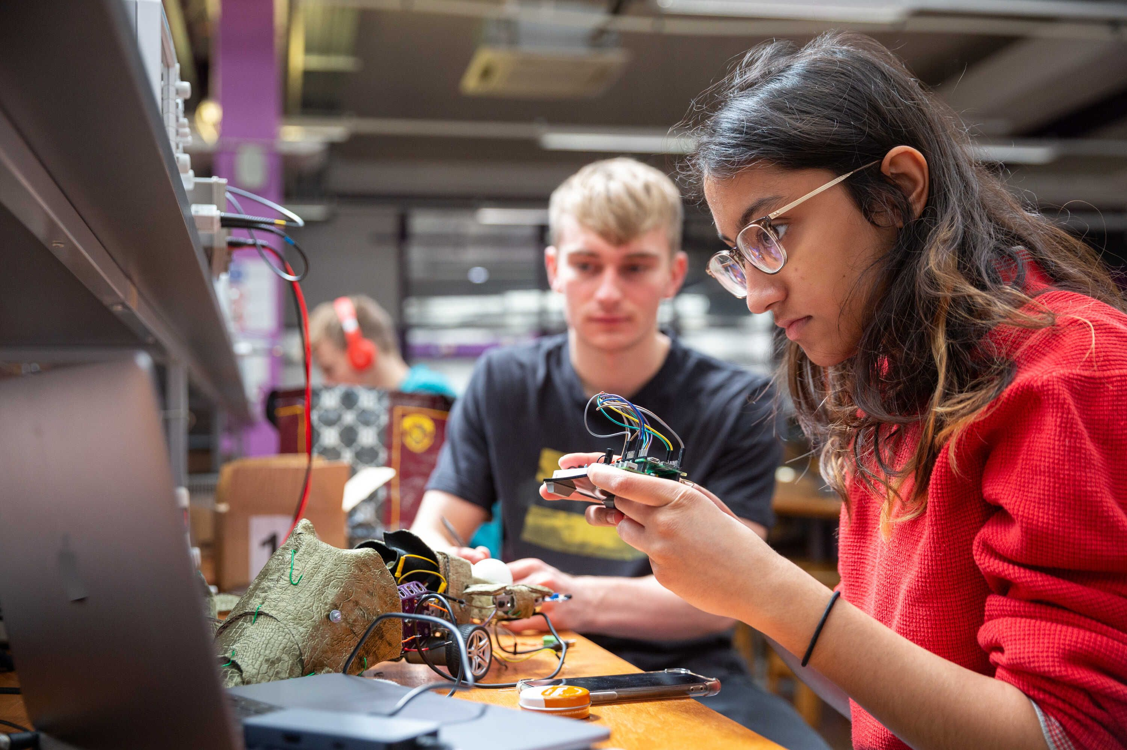

Engineer

Job Title:  Electrical Engineer | Electrical engineers design, build and maintain electrical systems, machinery and equipment.  Why become an Electrical Engineer? Watch the video in this link  https://www.bristol.ac.uk/engineering/why-study-electrical-and-electronic-engineering/  Want to learn more?  https://www.prospects.ac.uk/job-profiles/electrical-engineer
Entry requirements: | You can get into this job through:  - a university course  - a college course  - an apprenticeship  - working towards this role  - applying directly  University  You can do a degree in electrical or electronic engineering. You may also be able to get into this career with a degree in:  - electromechanical engineering  - building services engineering  - applied physics  - aeronautical engineering  - mechatronics  Entry requirements  You'll usually need:  - 3 A levels, or equivalent, for a degree  College  You could do a Level 4 and 5 Higher National Diploma in Electrical and Electronic Engineering at college before looking for work.  Entry requirements  You'll usually need:  - 2 A levels, a level 3 diploma or relevant experience for a level 4 or level 5 course  Apprenticeship  Apprenticeships relevant to this role include:  - Electrical or electronic technical support engineer degree apprenticeship  - Electro-mechanical engineer higher apprenticeship  These apprenticeships typically take between 4 and 6 years to complete.  You could start on an engineering technician apprenticeship and work your way up to qualified engineer.  Entry requirements  You'll usually need:  - 5 GCSEs at grades 9 to 4 and A levels, or equivalent, for a higher or degree apprenticeship  Work  You could start as an electrical engineering technician and do training on the job to qualify as an engineer.  Direct Application  You can apply for jobs if you've got qualifications and several years' experience in a related area of engineering, for example electronics.  More Information  You can find more details about careers and training from Electrical Careers and The Institution of Engineering and Technology.
Skills required: | You'll need:  - knowledge of engineering science and technology  - maths knowledge  - knowledge of computer operating systems, hardware and software  - design skills and knowledge  - to be thorough and pay attention to detail  - analytical thinking skills  - persistence and determination  - excellent verbal communication skills  - to be able to use a computer and the main software packages confidently  Restrictions and Requirements  You'll need to:  - take a colour vision test
What you'll do: | Your day-to-day tasks will depend on the industry you're in. You could:  - carry out feasibility studies for new technical developments  - draw up project plans and circuit diagrams using computer-assisted engineering and design software  - estimate costs and project timings  - coordinate the work of technicians and craftspeople  - test installations and systems, and analyse test data  - make sure projects meet safety regulations  - oversee inspection and maintenance programmes  - attend meetings, write reports and give presentations
What you’ll earn: | - Starter – £20,000  - Experienced - £60,000  Average Salary - £40,000  These figures are a guide
Working hours, patterns and environment: | You may work between 35 - 40 hours per week, including occasional evenings.  You could work in a factory, at a power station, in a workshop, at a research facility or in an office.  Your working environment may be at height.
Career path and progression: | You could work in different industries, from power and renewable energy to transport, construction and manufacturing.  You can improve your career prospects with incorporated or chartered engineer status.  Chartered status can help you move into electrical design and project management roles, specialise in a particular field, or work as an engineering consultant.  The Engineering Council have further details on how to become a chartered engineer.  You could also teach in a further education college.  Find out more about teaching in further education from Teach in further education.

