Job Title: Climatologist
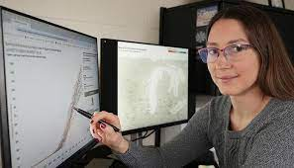
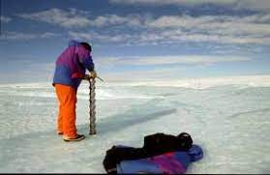

Job Title:  Climatologist | Climate scientists study changes in the Earth's climate over time and how they might affect the planet in the future.  Why become a Climatologist? Watch the video in this link  https://www.youtube.com/watch?v=h9_k6vZypoY  Want to learn more?  https://www.environmentalscience.org/career/climatologist
Entry requirements: | University  You could do a degree or postgraduate qualification in a relevant subject like:  - environmental science or ecology  - geography, earth sciences or geology  - physics  - maths and statistics  - oceanography or marine science  - meteorology and climate science  - computer science  Work experience  You can get work experience through internships, placements or a year in industry during your course. This may help you to identify your area of interest for research.  For example, the Met Office runs both summer placement and year in industry schemes.  Entry requirements  You'll usually need:  - 3 A levels, or equivalent, including maths and a science for a degree  - a degree in a relevant subject for postgraduate study
Skills required: | You'll need:  - maths knowledge  - knowledge of geography  - knowledge of physics  - excellent verbal communication skills  - science skills  - knowledge of computer operating systems, hardware and software  - the ability to work well with others  - to be thorough and pay attention to detail  - to be able to use a computer and the main software packages confidently
What you'll do: | You could:  - gather and analyse data from the atmosphere, oceans and land  - create computer models to simulate the effects of climate change  - design and build scientific instruments and sensors  - study past climates to understand what might happen in the future  - monitor ice, sea levels and temperatures  - look at how global climate affects regional weather  - attend conferences and publish research findings  - investigate ways to tackle climate change  - advise policy makers  - teach or lecture in education
What you’ll earn: | - Starter – £27,000  - Experienced - £55,000  Average Salary - £38,000  These figures are a guide
Working hours, patterns and environment: | You could work in a laboratory, at a university or visit sites.  Your working environment may be outdoors some of the time.  You would typically work office hours from Monday to Friday.
Career path and progression: | You could specialise in an area of climate science, for example polar research, rainfall patterns or ocean changes. You might do this through research and teaching at a university or by working for a government department.  You could also work as a paleo-climatologist, studying historic variations in climate and how the Earth adapted to these.  Other career options include working as a consultant for science publishers or broadcasters.  You may be able to apply for chartered environmentalist status. You can find out more about being a chartered environmentalist from the Society for the Environment.  Career tips  You can find information about global climate conditions through:  - NASA  - Intergovernmental Panel on Climate Change  Further information  Discover more about working in climate science from:  - UK Research and Innovation  - the Royal Meteorological Society  - the Natural Environment Research Council

